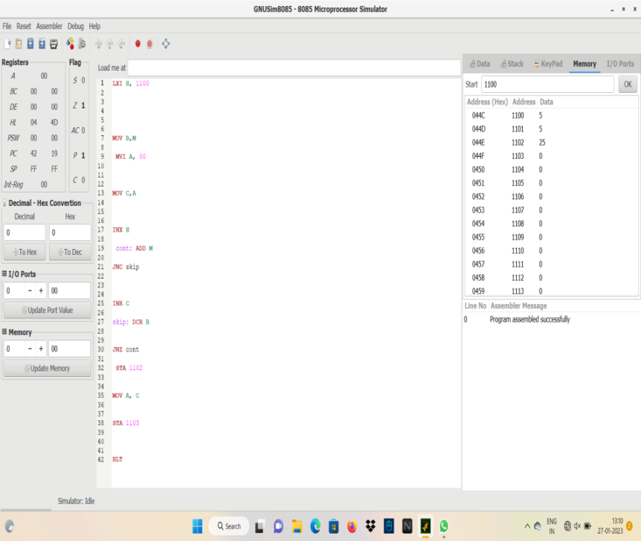5. Write an assembly language program for multiplication of two 8-bit data A7 A6 A5 A4 A3 A2 A1 A0 and B7 B6 B5 B4 B3 B2 B1 B0 using 8085 processor.

Program:

LXI H, 1100

MOV B,M

MVI A, 00

MOV C,A

INX H

cont: add M

JNC skip

INR C

skip: DCR B

JNZ cont

STA 1102

MOV A, C

STA 1103

HLT